Accessibility features:

Name the language in html files

<html dir="LTR" lang="en-GB">

This tell screen readers or text to speech brewers to read the page in British English and to read the page from left to right.   
Browsers can also know these what langue the page in and are more easily able to translate it.

This can also help search engines to know the langue and use it in search parameters.

Adding Titles

<title>Daniel Standring's Portfolio</title>

I have added titles to all pages. These will be the first thing read out by screen readers, so they will instantly now the title of my web page. Adding appropriate titles can also help optimisation for search engines.

Using alt for images

<img src="PhotoOfMe.jpg" alt="Photo of Daniel Standring"> having alts for text will allow those using screen readers to know what an image is of. This can help those who are hard of sight who might not be able to make out the image and would be helpful to the blind. This for any reason your image can not be displayed, alt will display that text.

Use of title attribute to hyperlinks

I have added titles to hyperlinks to add more information about where links go. This is also helpful for those using screen readers.



Use of fonts

I have use Arial font on all non-header text in my document. Normal text dose not really need to be styled like headings and titles, and a focus when choosing a font should be on readability. Arial can be easy to read for people with learning difficulty such as dyslexics like myself.

Navigation bar:

Having my navigation bar on all pages increases the usability of the webpage as they can navigate to any page of the website from any page. It is improved further as my navigation bar will remain at the top of the page even when scrolling down the page. This will allow the uses to more easily navigate the website without even needing to scroll up, improving usability

Headers

I have made good use of hierarchical heading. The main website title is h1, page headings are h2 and any sub headings are h3 or h4. These will help those using screen readers make better since of your website

Errors and Validation

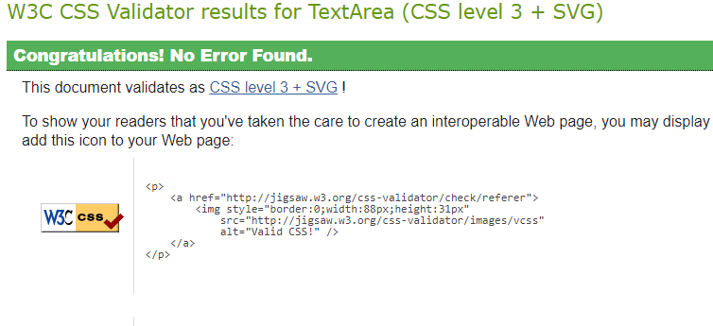

I had validated my CSS using W3schools validators and it had no errors

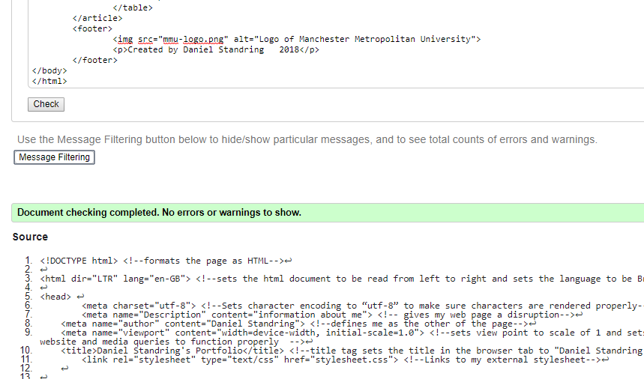

I also validated my HTML to find no errors.

Having valid code ensures that web pages and stylesheets can be rendered by assistive technology devices such as screen readers and braille displays. Having valid code will also insure code will work correctly and your web site usability will not be compromised by errors

Use on Mobile/ tables

I have made use of media quires and use of width percentages to create a responsive website on a range of devices. This will help improve usability on non-desktop devices, as well as when viewing the website in windowed mode on a desktop browser. Here is how my website will look on mobile.

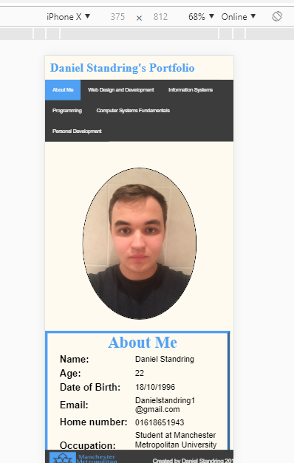

Emphasis - <em>

I have added an em tag to the first sentence of my web page, so it will be emphasised for those using screen readers.